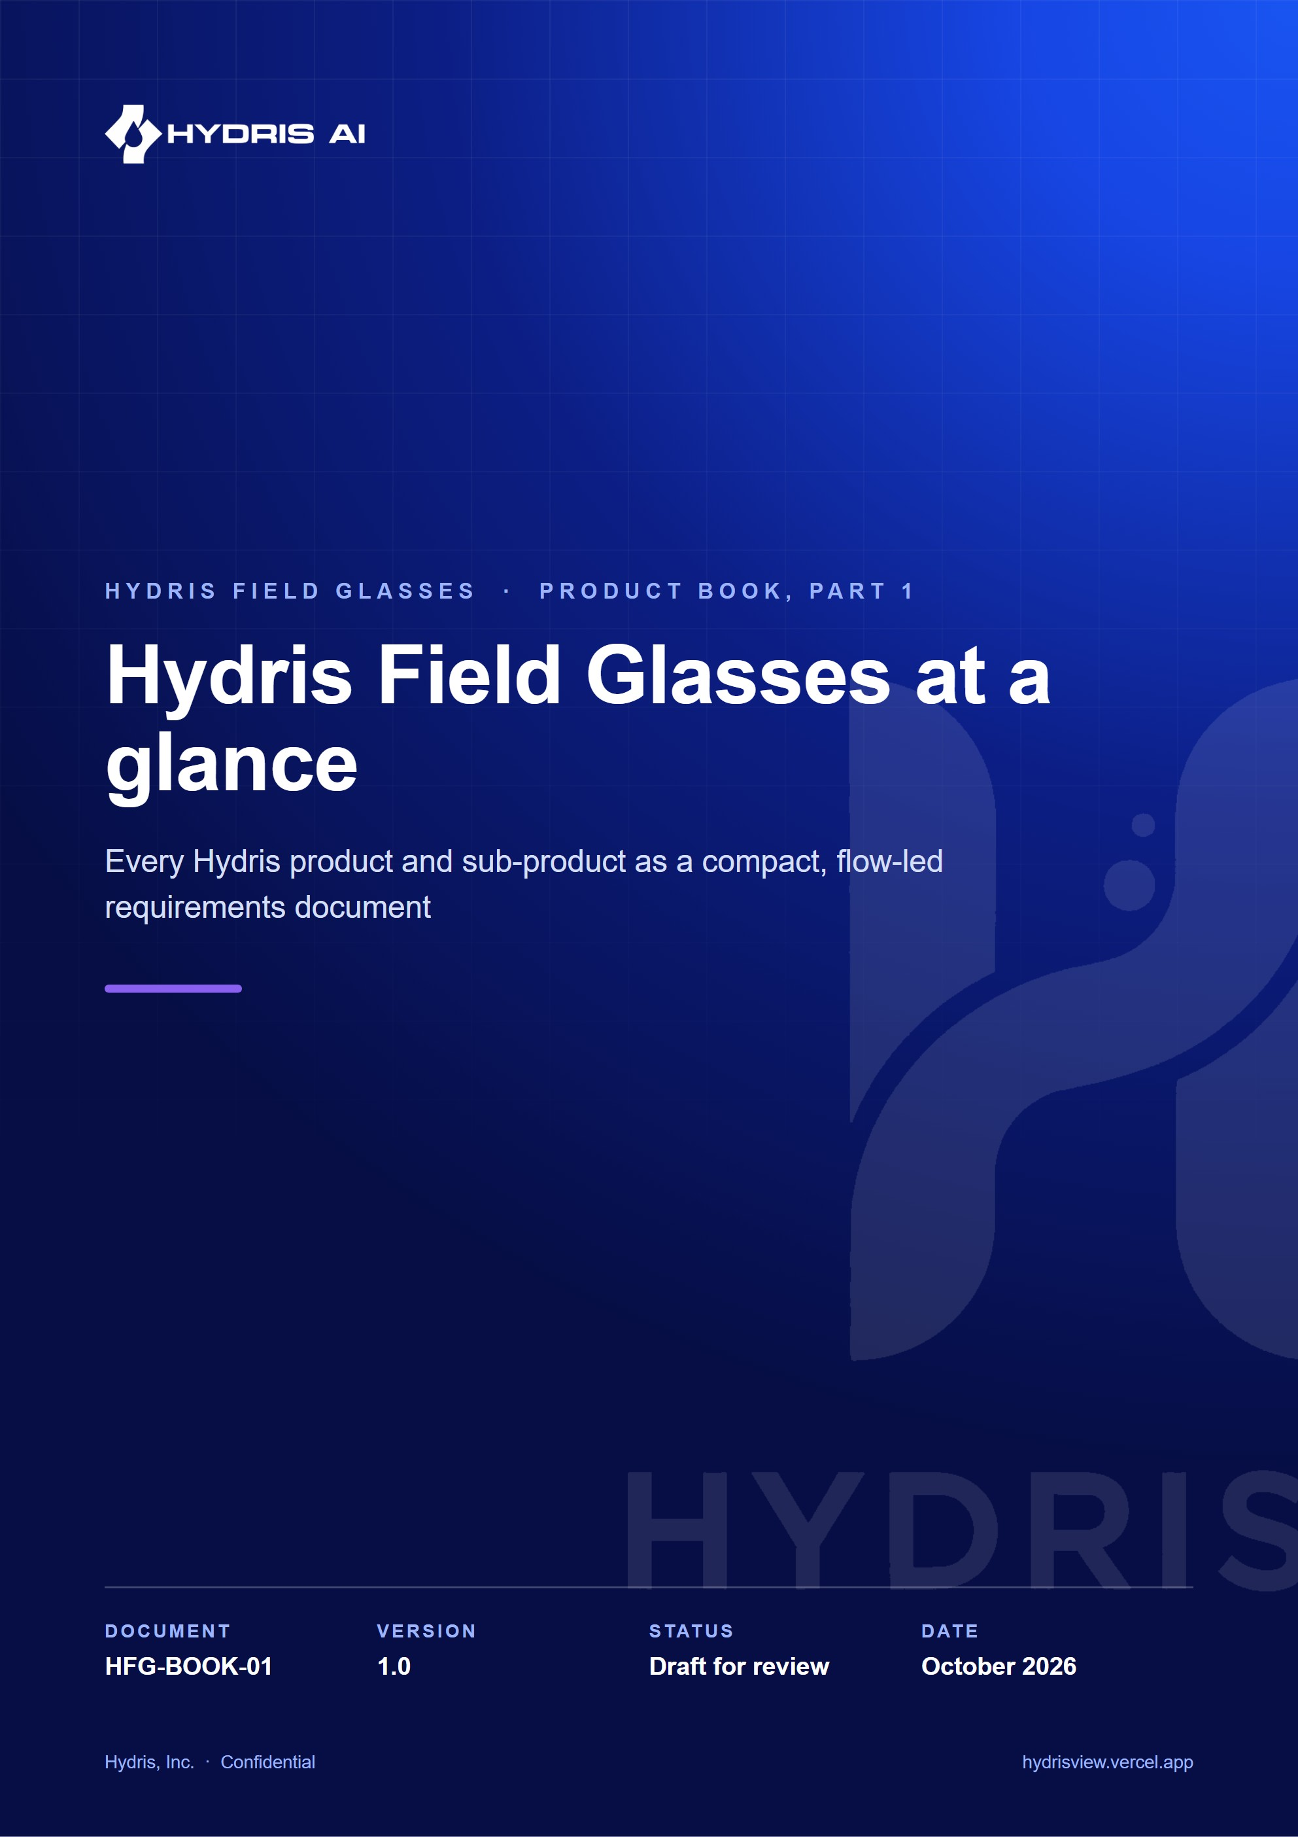
Document control
Document | Hydris Field Glasses at a glance (HFG-BOOK-01)
Version | 1.0
Status | Draft for review
Owner | Product and engineering, Hydris
Audience | Leadership, product, engineering, design, partners and pilot customers
Product | Hydris Field Glasses: website, operator console, glasses app, Android app, API
Source of truth | docs/product/_part01.md in tarun-km/hydrisview (this Word file is generated from it)
Classification | Confidential: Hydris, Inc. and named partners
Revision history
Version | Date | Author | Changes
1.0 | October 2026 | Product and engineering, Hydris | First edition

Contents
1 Hydris Field Glasses at a glance 4
1.1 Executive summary 4
1.2 Vision and principles 4
1.3 The problem in wastewater plants 5
1.4 Personas and jobs 6
1.5 The product family 7
1.6 One account, every surface 8
1.7 The operator's day 8
1.8 The core loops 9
1.9 Status, gaps and the path to pilot 11
1.10 How to read this book 12

1 Hydris Field Glasses at a glance

1.1 Executive summary
Wastewater operators spend their shift walking the plant: reading instruments, checking pumps and blowers, sampling effluent, writing values on paper and responding to alarms that usually reach a control room before they reach the person standing next to the equipment. The records they leave behind are the evidence a plant shows its regulator, and much of that evidence is still on paper.
Hydris Field Glasses puts the live state of the plant, the next task and the approved procedure in the operator's line of sight, hands free, and turns every reading, check and paper record they touch into a record that can be trusted. It does this through a family of connected products that share one API, one tenant model and one permission matrix: a public website with a live demo, an operator console, a glasses heads-up app, the native Android app Hydris Field, a Ray-Ban Meta integration, audit scanning, a grounded voice assistant and the platform underneath.
5  product surfaces  website, console, glasses app, Android app, API |  | 143  API routes  across 15 modules |  | 67  automated tests passing  26 domain + 41 API, 22 Oct 2026 |  | 10  demo scenarios  deterministic, demo tenants only

6  roles  38 permissions, one fixed matrix |  | 16  measurands  pH to residual chlorine |  | 12  glasses screens  six-key directional input |  | 42  database tables  row-level security on every tenant table

The platform core is Built and runs at https://hydrisview.vercel.app in demo mode, with named guest accounts on synthetic plant data. The main gaps before a customer pilot are validation of the glasses paths on physical Ray-Ban Meta hardware, email delivery for invitations and password resets, continuous integration, a scheduled-job cadence suited to real data on serverless hosting, and an offline outbox in the Android app. The plan sequences these into hardening in Q4 2026, a pilot at one or two Indian plants in Q1 2027 and general availability in Q2 2027 (plan, not commitment).
DECISION
Hydris is read-only towards the plant. It never writes to PLCs, SCADA or equipment. The grounded assistance endpoint states "Hydris does not control equipment" in every response, and every voice-assistant tool is read-only. This keeps Hydris outside the plant's control-system safety case.

1.2 Vision and principles
Vision. Every operator in a water or wastewater plant sees what matters, does the next right thing and leaves behind a record that stands up to an audit, without putting down their tools. In three years we want Hydris to be the default way an Indian ETP, STP or CETP runs its rounds, responds to alarms and keeps its compliance records.
Four principles carry most of the weight. When requirements conflict, they decide.
Table 1. The four principles that shape every Hydris product
Principle | What it means for users | How the product enforces it
Advisory only | Hydris informs and guides; people operate the plant | No write path to equipment; assistant tools are read-only; safety notice on every grounded answer
Hands-free | Every operator action works with six directional keys or voice; the camera runs only on intent | Glasses input vocabulary (up, down, left, right, select, back); "Hey Hydris"; camera only on scan screens
Grounded | A number is never a guess; every value has a source and an age | Freshness states (live, delayed, stale, no data); provenance on every reading; assistant answers only from tool results
Human verification | Machines propose, a person confirms, a different person approves | Audit document review and four-eyes approval; corrections append, originals stay visible

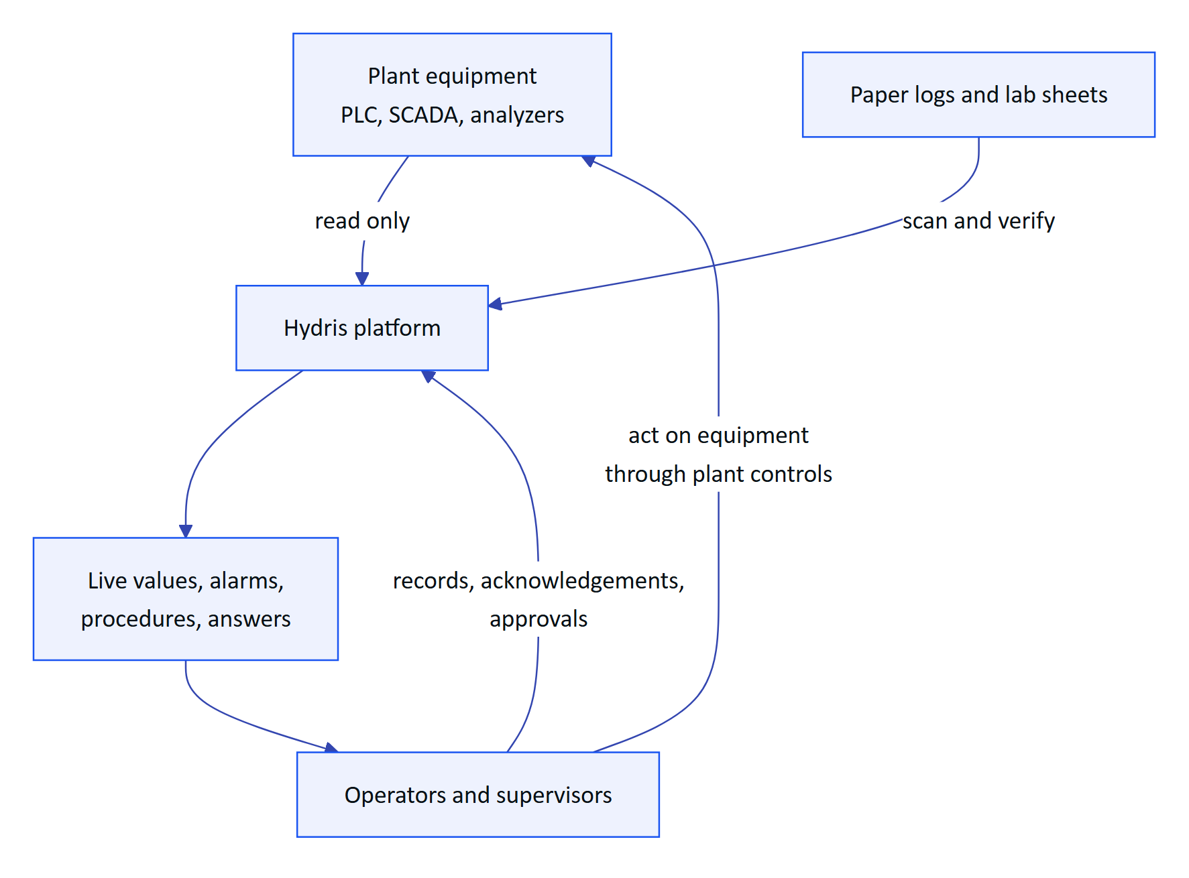
Figure 1. The advisory boundary: Hydris reads from the plant and informs people, who stay in control
Hydris sits beside the control system, never inside it. Data flows in from instruments and paper; decisions and actions stay with people, who use the plant's own controls.

1.3 The problem in wastewater plants
Effluent, sewage, water and common effluent treatment plants (ETPs, STPs, WTPs, CETPs) run continuously, with operators walking fixed rounds through intake, equalization, aeration, clarification, filtration, disinfection, sludge handling and the discharge point. Four problems recur:
- Paper rounds drift from reality. Readings are written on clipboards and transcribed later. Nobody can tell which value was observed and which was copied.
- Alarms reach the wrong person. The operator nearest the pump finds out last, and acknowledging an alarm gets confused with fixing it.
- Compliance evidence is unsearchable. Logbooks, lab sheets and checklists are paper, so producing evidence for an inspection means digging through files.
- Phones are the wrong tool at the asset. Gloves, ladders, wet hands and sampling bottles make phones awkward.
Indian compliance context. Discharges are regulated under the Water (Prevention and Control of Pollution) Act, 1974, through consents to establish and operate issued by State Pollution Control Boards (SPCBs) and Pollution Control Committees. General discharge standards are set under the Environment (Protection) Rules, 1986, with plant-specific limits in each consent. In 2014 the Central Pollution Control Board (CPCB) directed the 17 categories of highly polluting industries, and CETPs, to install online continuous effluent and emission monitoring systems (OCEMS) connected to CPCB and SPCB servers.
NOTE
Hydris does not certify compliance and is not a certified OCEMS. It produces records (telemetry with provenance, inspection results, verified documents and an append-only audit trail) that make compliance easier to demonstrate. OCEMS analyzers can feed Hydris through the gateway ingestion API so operators see the values the regulator sees.

Why now. Camera glasses such as Ray-Ban Meta are light, affordable and acceptable on a plant floor; Meta opened a device access toolkit (DAT) to third-party apps; and language models can now answer spoken questions from structured plant data reliably enough to help, provided they are grounded and constrained.

1.4 Personas and jobs
Six personas map onto the six roles in the permission matrix; a seventh, the Hydris platform administrator, is a flag on the user.
Table 2. Personas, primary surfaces and top jobs
Persona | Role | Primary surface | Top jobs
Field operator (Ravi) | Field operator | Glasses, Android app | Walk the round, see live values at the asset, acknowledge alarms, scan paper logs, ask by voice
Shift supervisor (Meena) | Supervisor | Console, Android app | Dispatch rounds, triage and assign alarms, review inspections, verify scans
Maintenance engineer (Arjun) | Maintenance engineer | Android app, glasses | Work orders and checklists, resolve alarms, SOPs at the asset
Plant manager (Priya) | Factory manager | Console | KPIs and reports, alarm rules, approve documents, decide what the glasses show
Compliance auditor (Mr Rao) | Viewer with report access | Console, PDF exports | Read approved records and their verification trail; never change anything
Organization admin | Org admin | Console | Members, invitations, sites, glasses UI profiles
Platform admin | Platform flag | Console platform page | Create and suspend customer organizations

Table 3. Jobs to be done
Job | When ... I want ... so that ...
J1 Round | When I start my round, I want my inspections in order, so I do not miss an asset
J2 Trust | When I stand at an asset, I want its live readings and their age, so I can trust what I record
J3 Alarm | When an alarm fires near me, I want to acknowledge it and see the action and SOP, so the right person is accountable
J4 Evidence | When I fill a paper log, I want to capture it once and have it verified, so the record is searchable and defensible
J5 Voice | When my hands are busy, I want a short spoken answer grounded in our data
J6 Control | As a manager, I want to control what each role sees on the glasses without an app update
J7 Devices | As an admin, I want to pair, reassign, suspend or revoke glasses in seconds
J8 Audit | As an auditor, I want every approved document traceable to a person and a time
J9 Evaluate | As a prospect, I want to try the product in minutes without talking to sales

1.5 The product family
Hydris is one platform with eight products. Each has its own part in this book, written as a compact PRD.
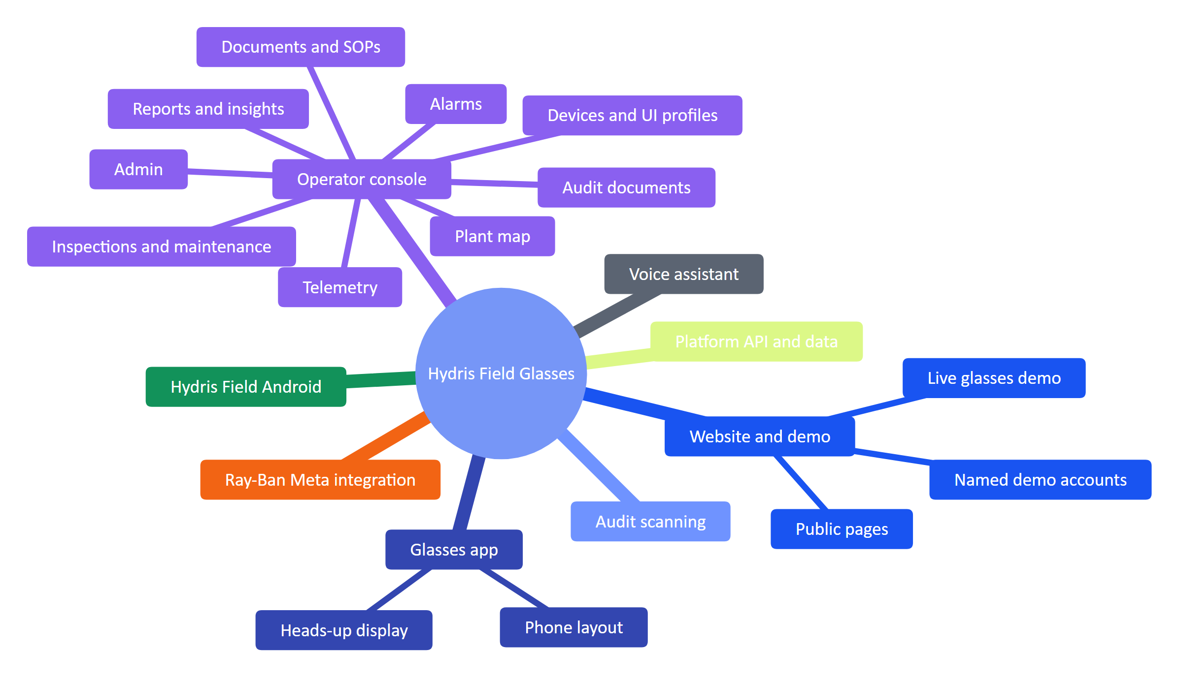
Figure 2. The Hydris product family and its sub-products
Table 4. Products, what they do and where they stand
Product | What it does | Status
Website and demo | Seven public pages, contact and demo request, live glasses demo, one-click named demo accounts | Built
Operator console | Sixteen sections in five groups (Operate, Work, Plant, People and devices, Insight) plus admin and platform pages | Built
Glasses app | Twelve heads-up screens with directional input, offline inspection queue, scan and voice; phone layout and browser simulator | Built (web); native display rendering Planned
Hydris Field Android | Sign-in, home, work, alarms, sensors, audit scan with on-device OCR, "Hey Hydris", glasses connection | Partial: built in code, glasses paths not validated on hardware
Ray-Ban Meta integration | Camera, capture button, microphone and speakers through Meta DAT 1.0.1; registration as a Hydris device | Partial: not validated on physical glasses
Audit scanning | Guided A4 capture, dual OCR, optional vision engine, field review, four-eyes approval, searchable PDF | Built
Voice assistant | Wake phrase, short spoken answers from tenant data through read-only tools, rules fallback | Built (English); other languages Planned
Platform API and data | 143 routes, row-level security, realtime events, append-only audit trail, demo mode | Built

1.6 One account, every surface
A user signs in once and gets the same permissions and data on the console, the glasses and the phone. Every surface talks to one API; the database enforces tenant isolation, not the application code.
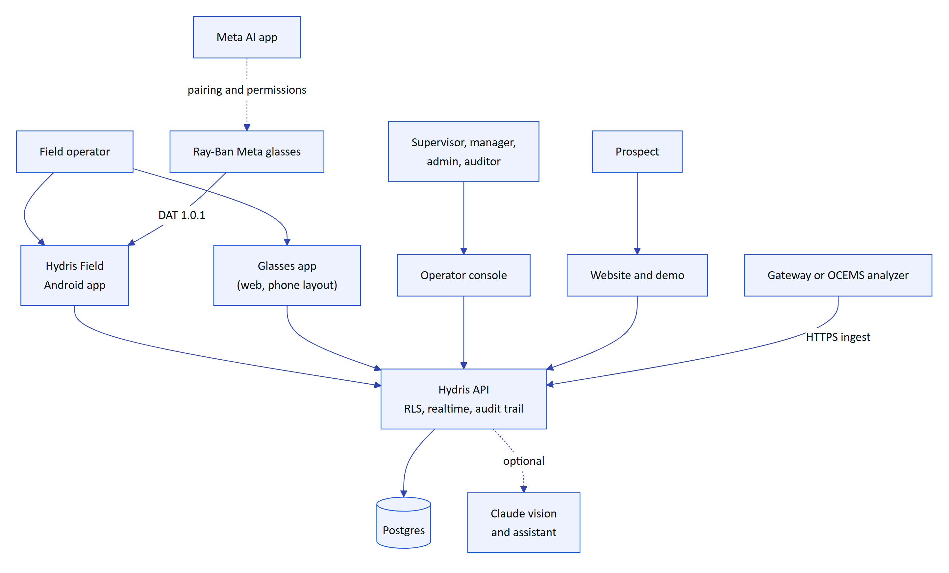
Figure 3. System context: people, Hydris surfaces and external systems
IMPORTANT
Ray-Ban Meta glasses reach third-party apps only through Meta's DAT, and they are paired and permissioned through the Meta AI app. That app must stay installed on every operator phone; Hydris Field checks for it and sends the user there to connect.

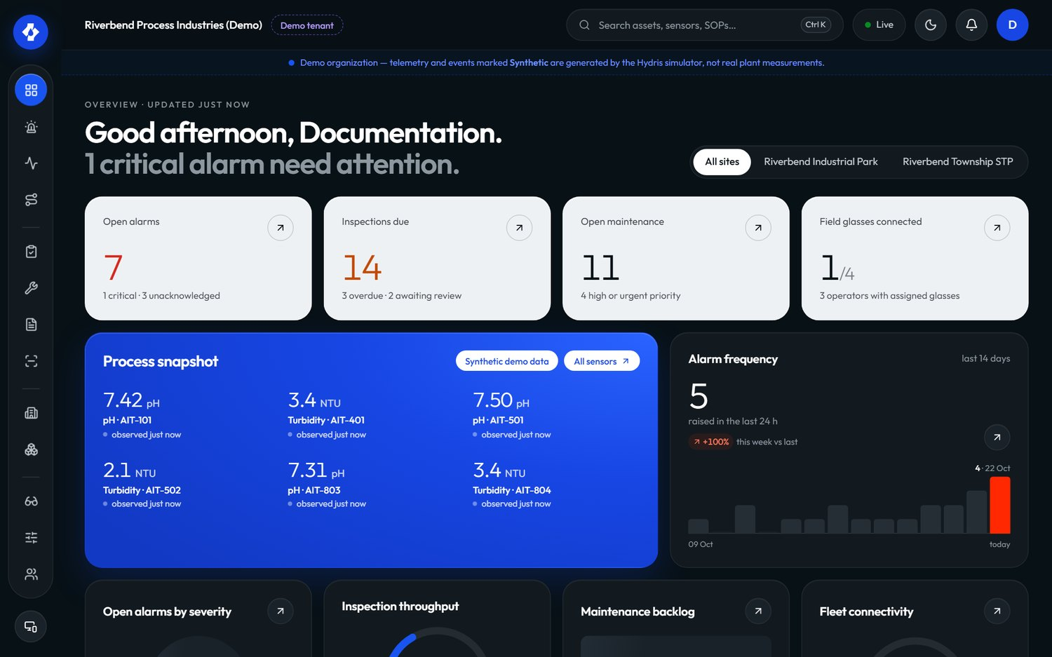
Figure 4. The operator console overview: KPIs, open alarms and live measurements

1.7 The operator's day
The journey below is the target state for a field operator across one shift. Scores are design targets (1 to 5), not measurements.
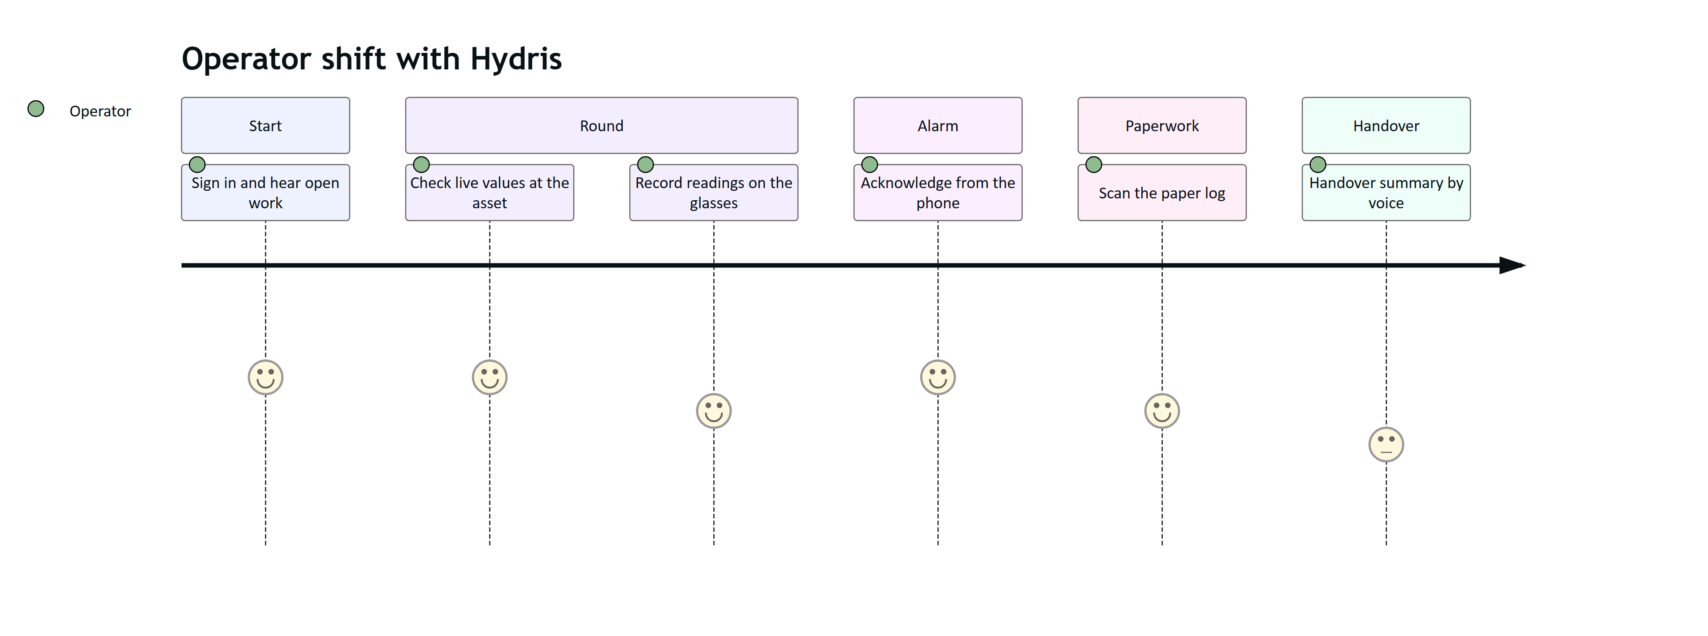
Figure 5. Field operator journey across one shift (target state)
The product is strongest today at alarm acknowledgement, scanning and voice lookups. The handover summary is Planned, and inspection execution on the Android app is Planned; rounds are executed in the glasses app today.
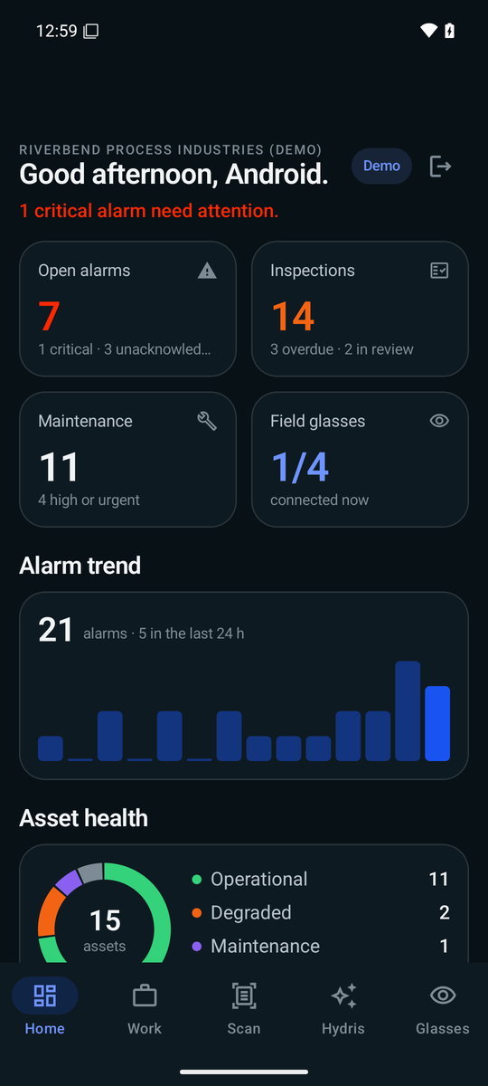
Figure 6. Hydris Field home: greeting, alarm trend, asset health and live measurements

1.8 The core loops
Four loops explain the whole product. Each crosses several products, which is why they share one platform.

See and act on the plant
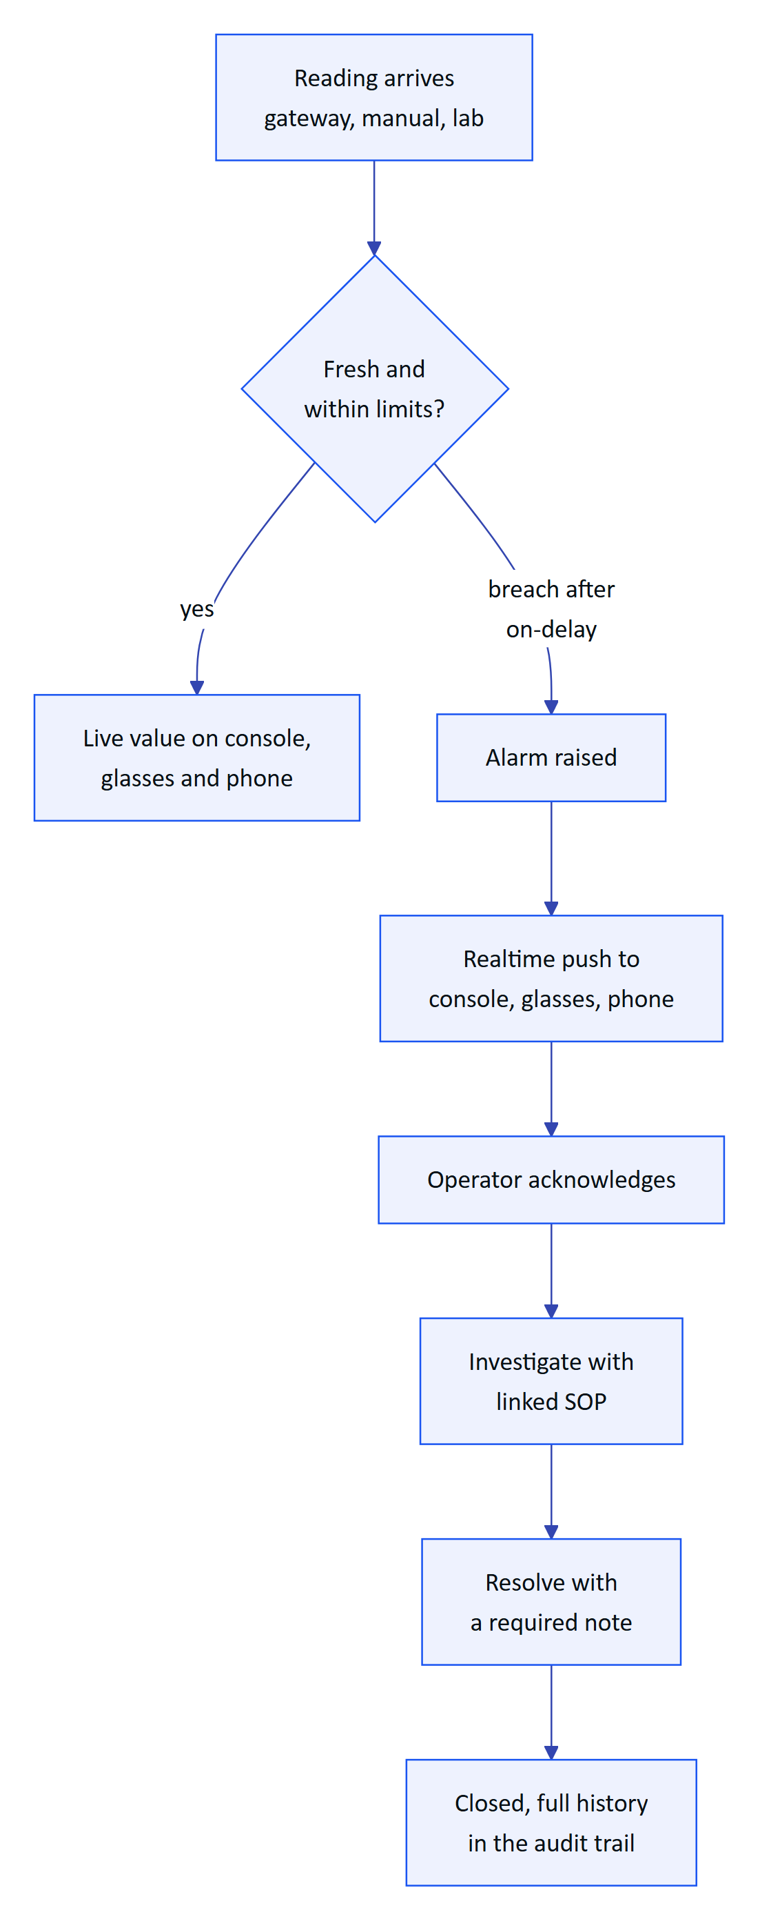
Figure 7. Loop one: a reading becomes an alarm, the right person acts and the record closes
Every reading passes one ingestion path with provenance. Alarm rules use deadband and on-delay so values that hover do not flap, and the lifecycle refuses to resolve an alarm without a note, so "acknowledged" is never mistaken for "fixed".

Do the work right
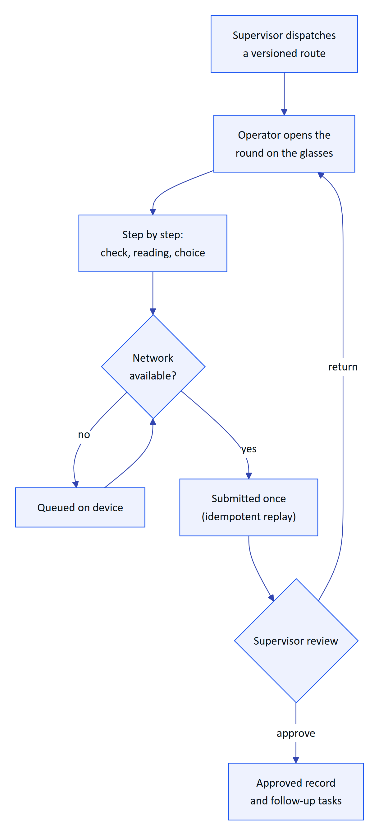
Figure 8. Loop two: a dispatched round is executed hands-free, even offline, and reviewed
Inspection templates are versioned, so a round keeps the version it was dispatched with. Responses are queued locally and replayed exactly once when the network returns.

Paper to verified record
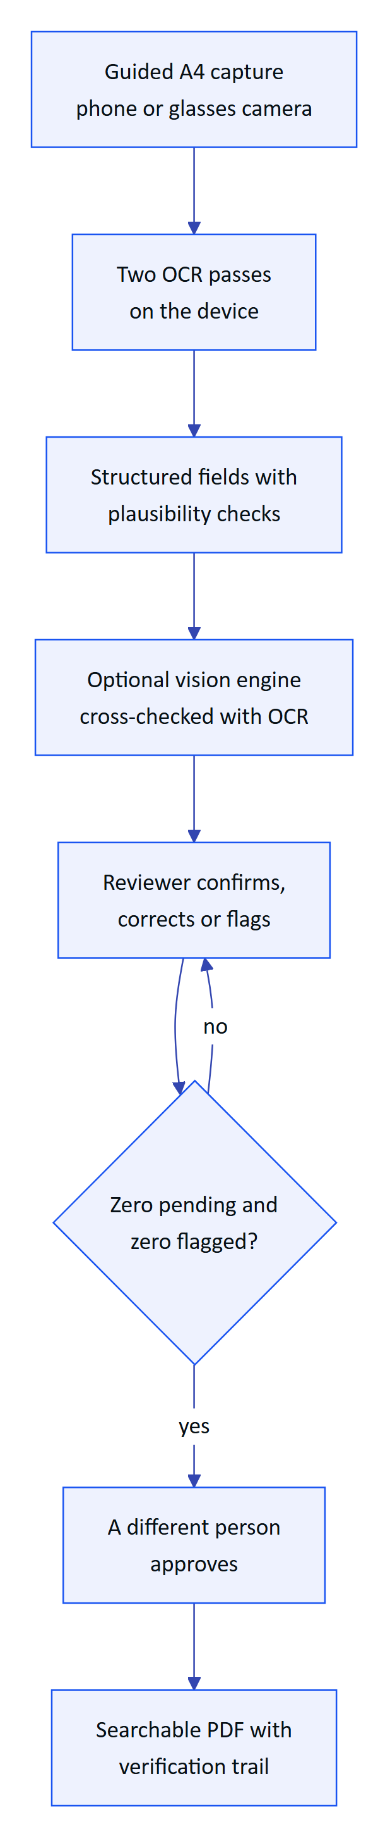
Figure 9. Loop three: a paper log becomes a verified, approved, searchable record
Machines propose and people decide. The original extracted value is kept beside every correction, and approval must come from someone other than the verifier, except in demo tenants where self-approval is allowed and recorded.

Ask the plant
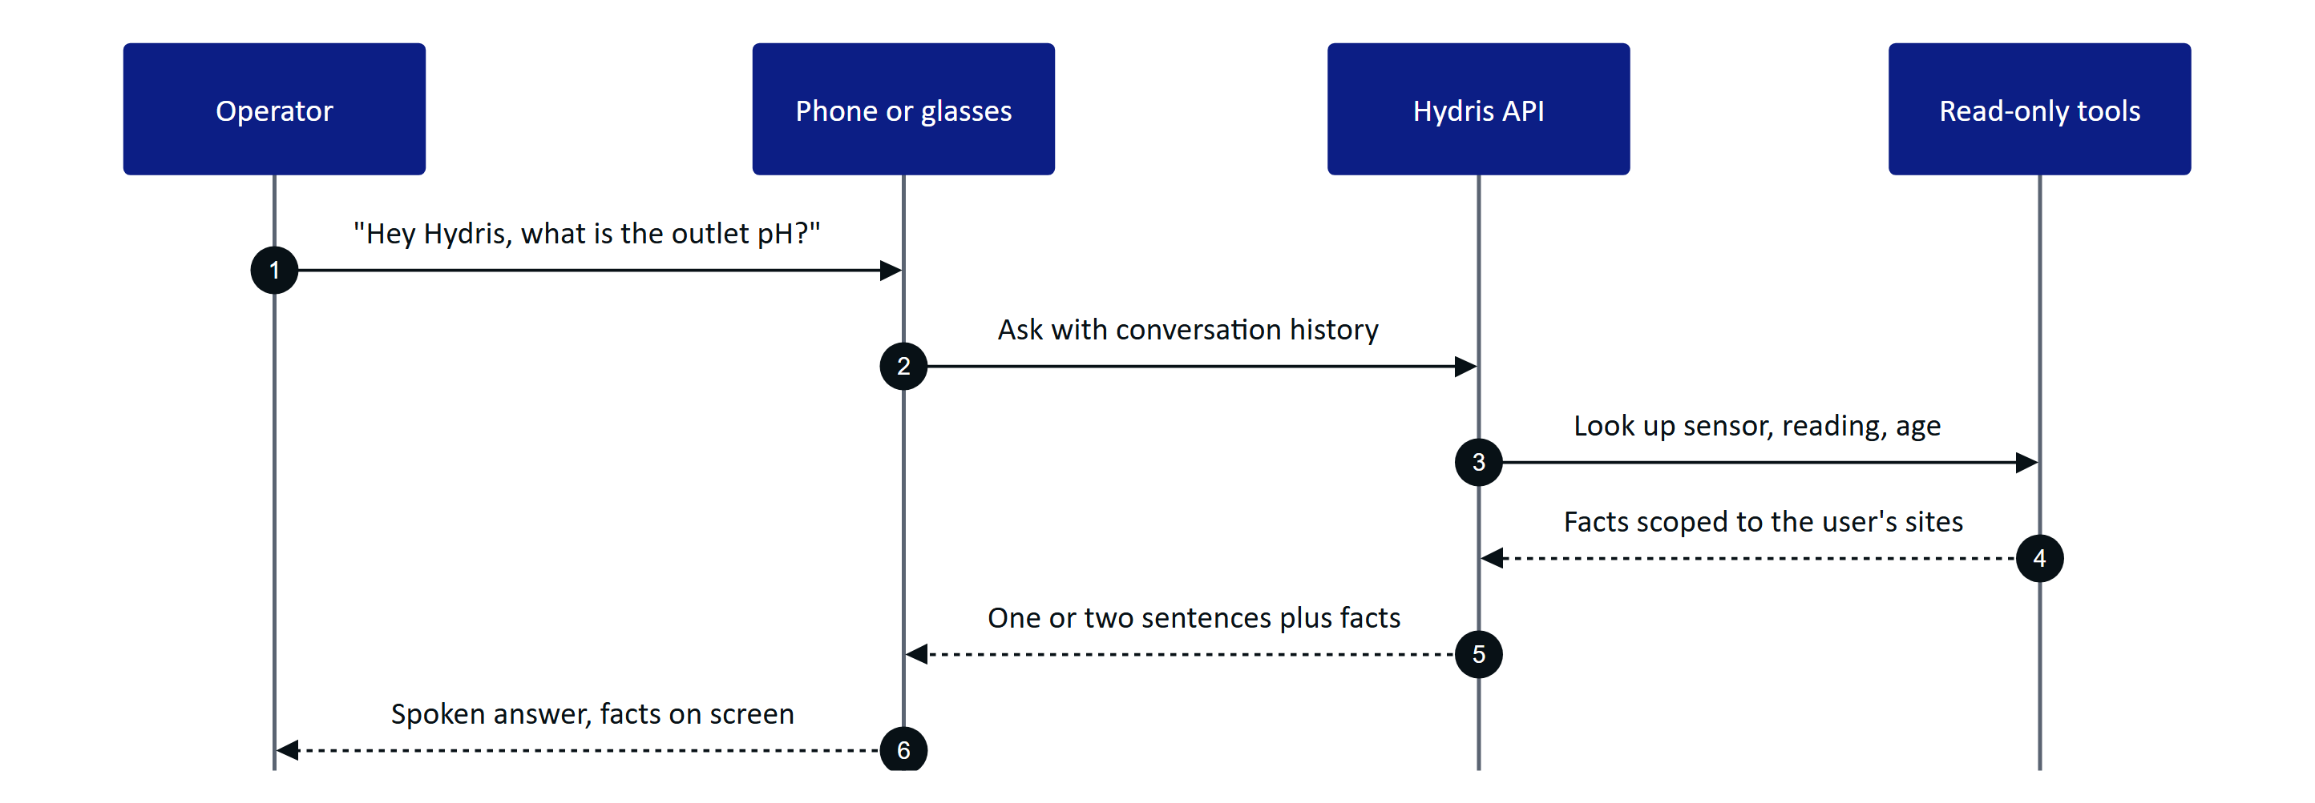
Figure 10. Loop four: a spoken question answered from the tenant's own data
The assistant answers only from tool results in the same conversation and states the age of each reading. If the model is unavailable, a rules engine answers instead, and an unknown question gets "can't answer", never a guess.

1.9 Status, gaps and the path to pilot
Table 5. Top gaps before a customer pilot
Gap | Effect today | Plan
Glasses paths not run on physical Ray-Ban Meta | Camera, capture button and glasses microphone are Partial | Hardware test matrix, Q4 2026 to Q1 2027
Email not sent | Invitations and resets sit in an outbox | Email transport in hardening, Q4 2026
No continuous integration | Regressions can reach the demo | CI gates on every change, Q4 2026
Daily cron on serverless hosting | Stale-data alarms evaluated once a day | Per-minute schedule, Q4 2026
No Android offline outbox | Phone actions need connectivity | Planned for GA, Q2 2027

North star  verified field records per active operator per week  rises only with real, trusted field use |  | 95 %  on-time rounds  pilot target |  | Under 5 min  median alarm acknowledgement  pilot target, critical and high |  | 0  hallucinated numbers  target for voice answers

1.10 How to read this book
Each product part follows the same spine: purpose and problem, users and jobs, scope, key flows, requirements (with the stable FR IDs from the PRD and status Built, Partial or Planned), experience notes, success metrics (targets labelled as targets) and status with next steps.
Table 6. Part map
Part | Read it if you want to know
Hydris Field Glasses at a glance | What Hydris is, for whom, and how the products fit together
Website and demo | How a prospect discovers and tries Hydris in minutes
Operator console and its sub-products | How supervisors, managers and admins run the plant, the work and the devices
Glasses app | What the operator sees and does on the heads-up display and phone layout
Hydris Field Android app | The native companion app for operators and engineers
Ray-Ban Meta integration | How the glasses' camera, button, microphone and speakers reach Hydris
Audit scanning | How paper becomes verified, approved evidence
Voice assistant | How "Hey Hydris" answers from plant data without guessing
Platform API and data | Tenancy, security, realtime and the shared data model underneath
Roadmap and future products | What comes next, in what order, and how we will know it worked

